Power BI Assignment - 1
Data Transformation & Data Modeling
Data Import & Transformation:
1. Data Import:
○ Import List of Orders.csv into Power BI.
○ Open the list of orders in the Power Query Editor using the Transform Data option.
○ Import Order Details.csv and Sales Target.csv into Power Query Editor.
ANS:
The datasets List of Orders, Order Details, and Sales Target were imported into Power BI using the Get Data option
All datasets were loaded into Power Query Editor for further transformation and preparation.
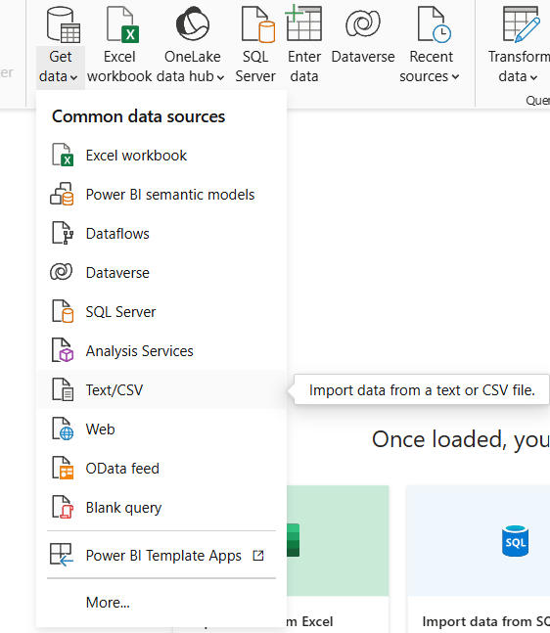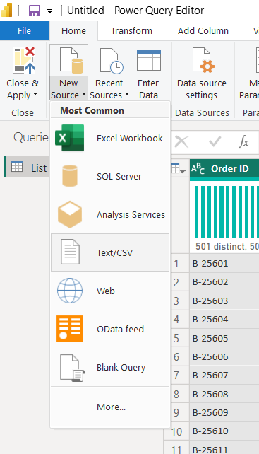
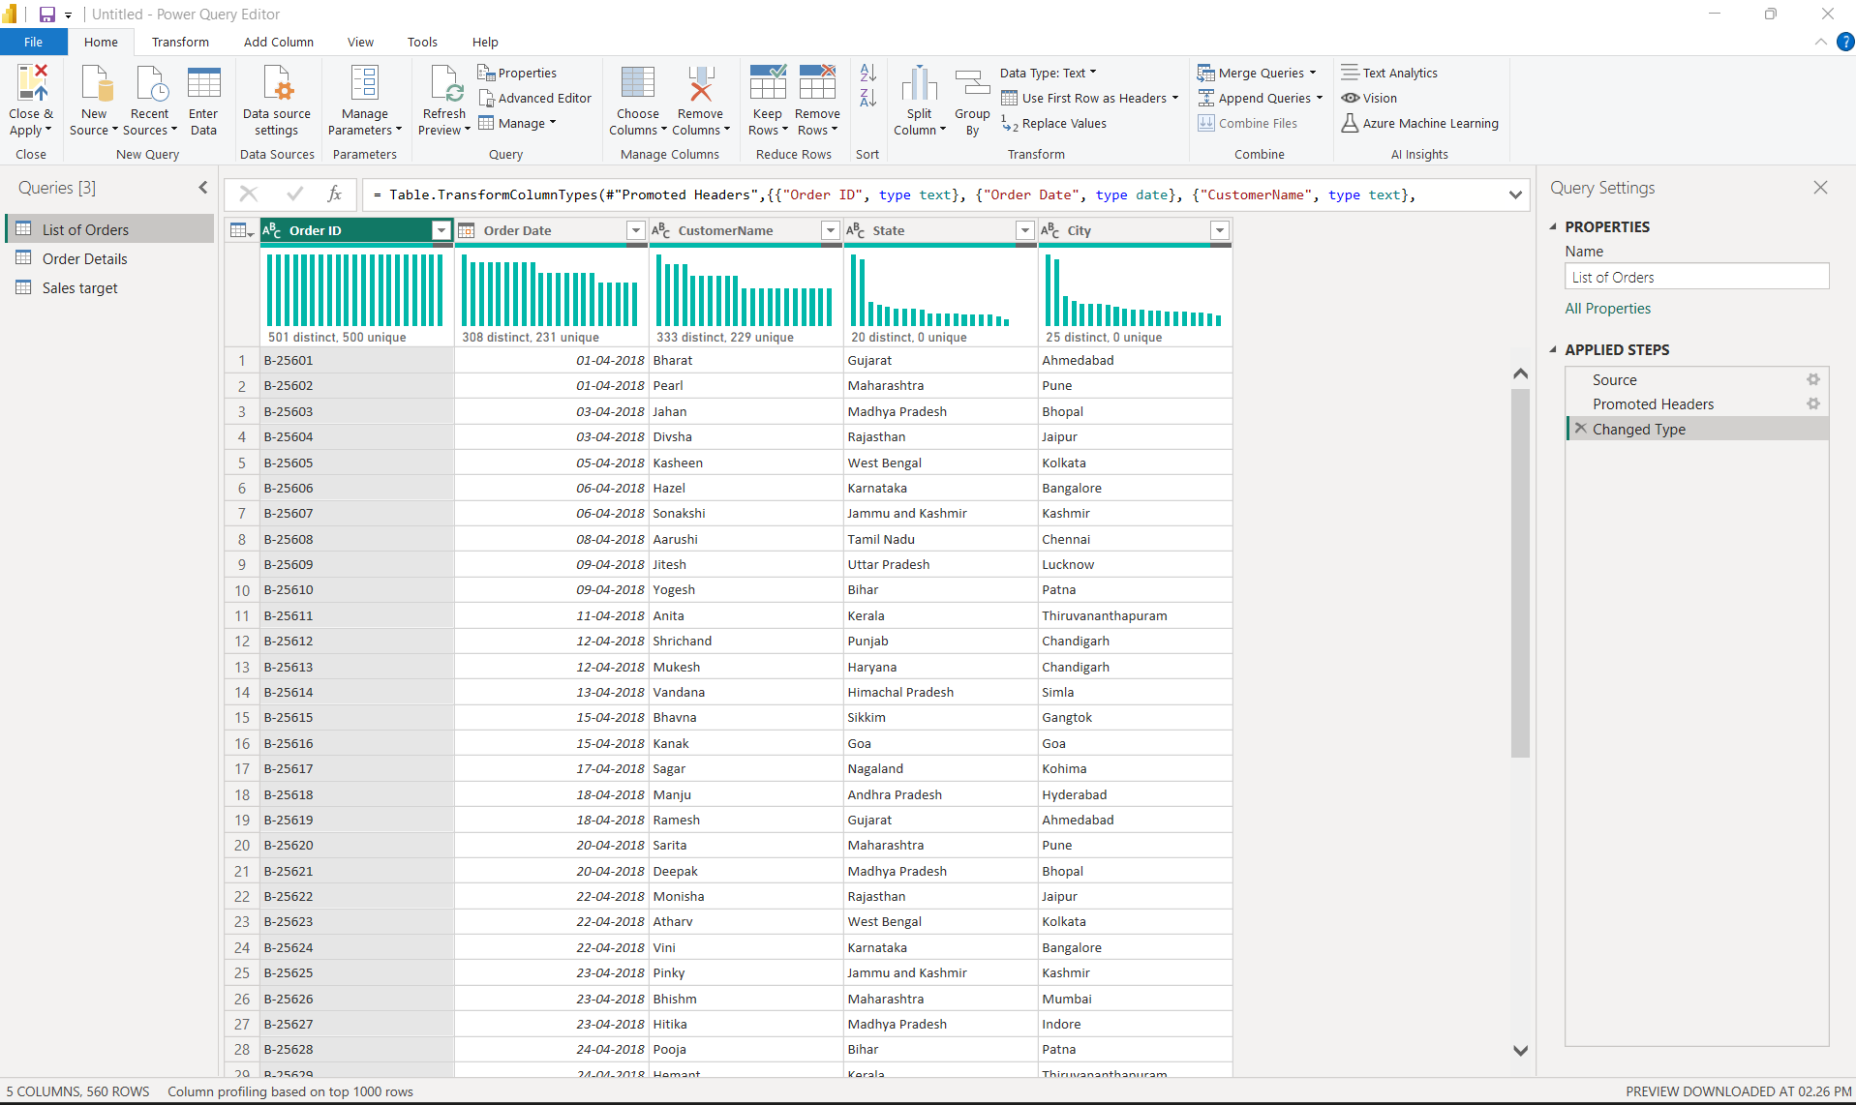
2. Row Limiting & Data Types:
○ Restrict the List of Orders table to the first 500 rows.
ANS:
The List of Orders table was restricted to the first 500 rows using the Keep Top Rows option in Power Query Editor
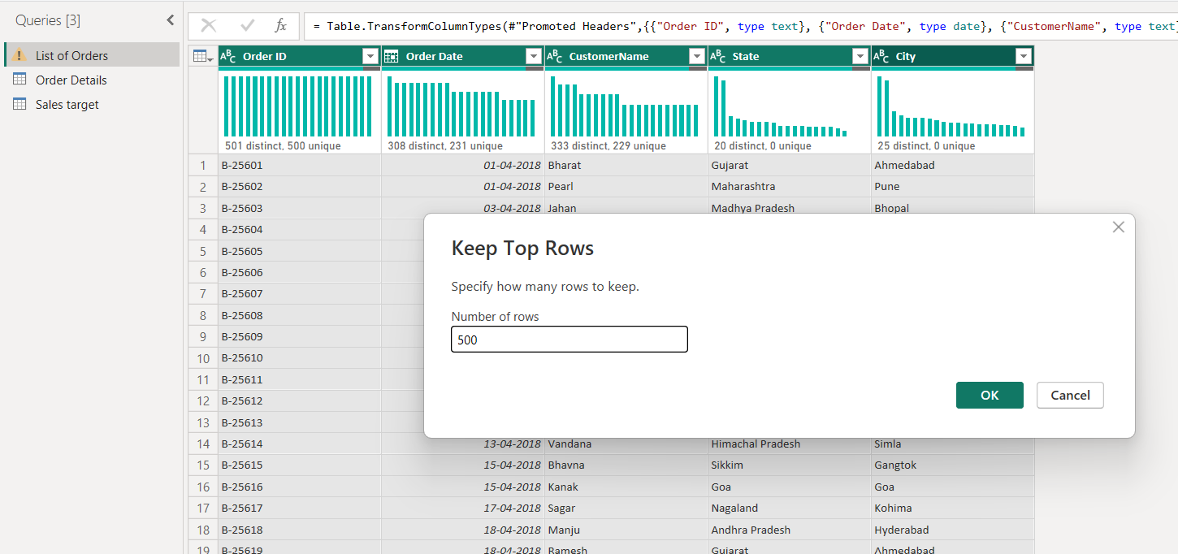

○ Set the Order Date column to the Date data type.
ANS: The Order Date column was converted into Date format by using change type option
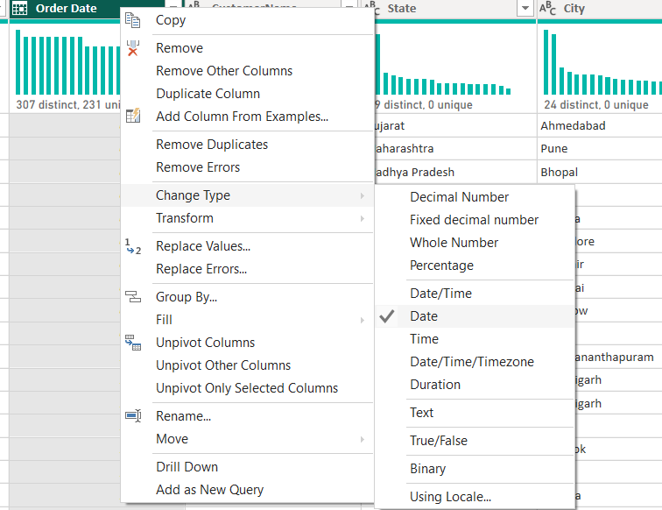

○ Change the Amount and Target columns to fixed decimal numbers.
ANS: The Amount and Target columns were changed to Fixed Decimal Number format

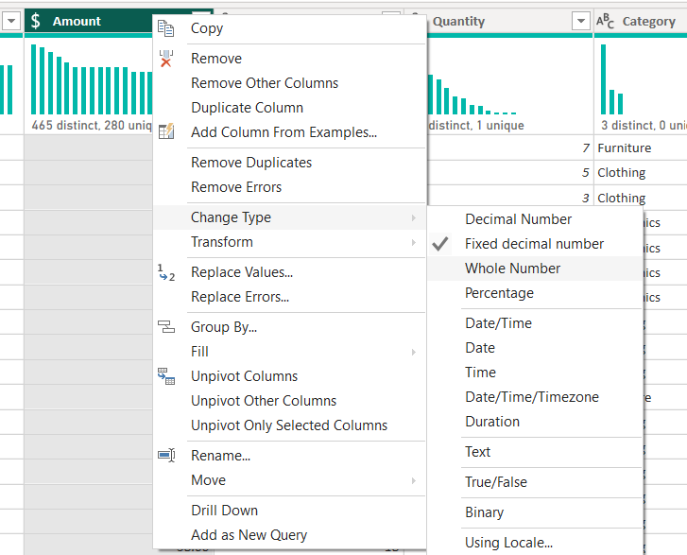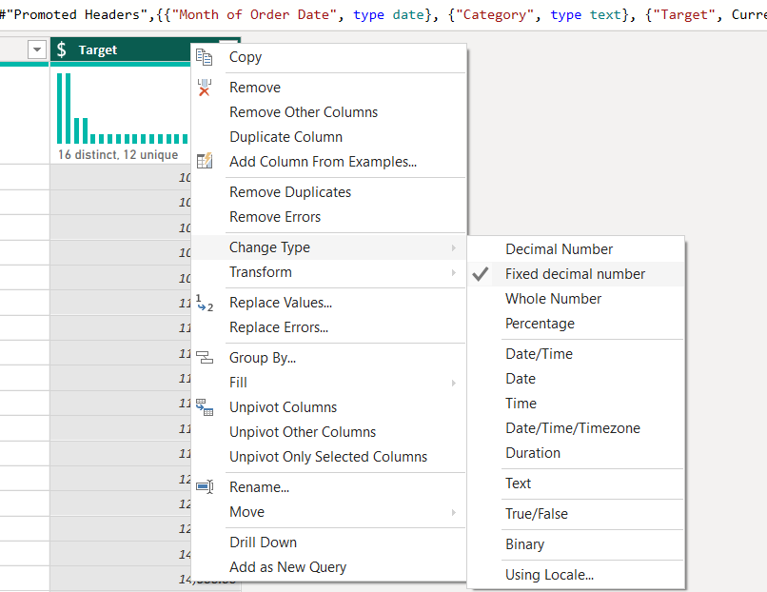

3. Text Formatting:
○ Format the Customer Name column to proper case to ensure consistent capitalization.
ANS: The CustomerName column was formatted using the Capitalize Each Word option to ensure consistent text formatting and proper capitalization throughout the dataset
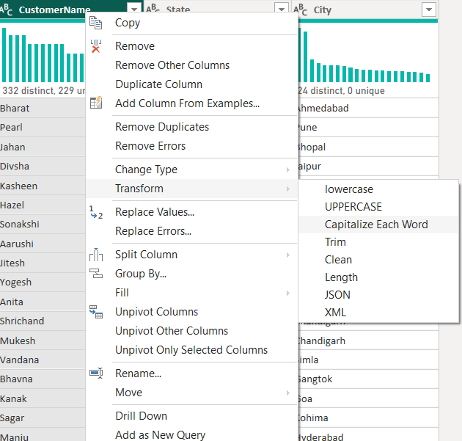
4. Column Creation:
○ Merge the City and State columns to create a new column named Location in the format:
City, State
ANS: The City and State columns were merged to create a new column named Location in the format “City, State”
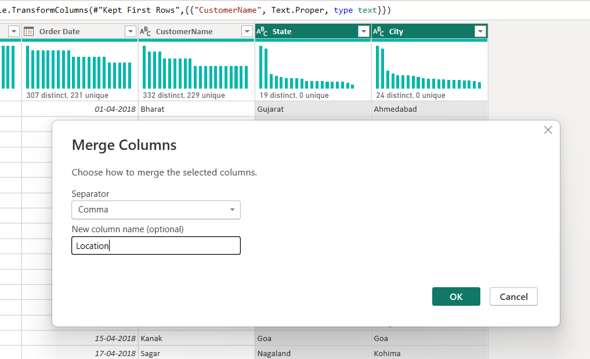

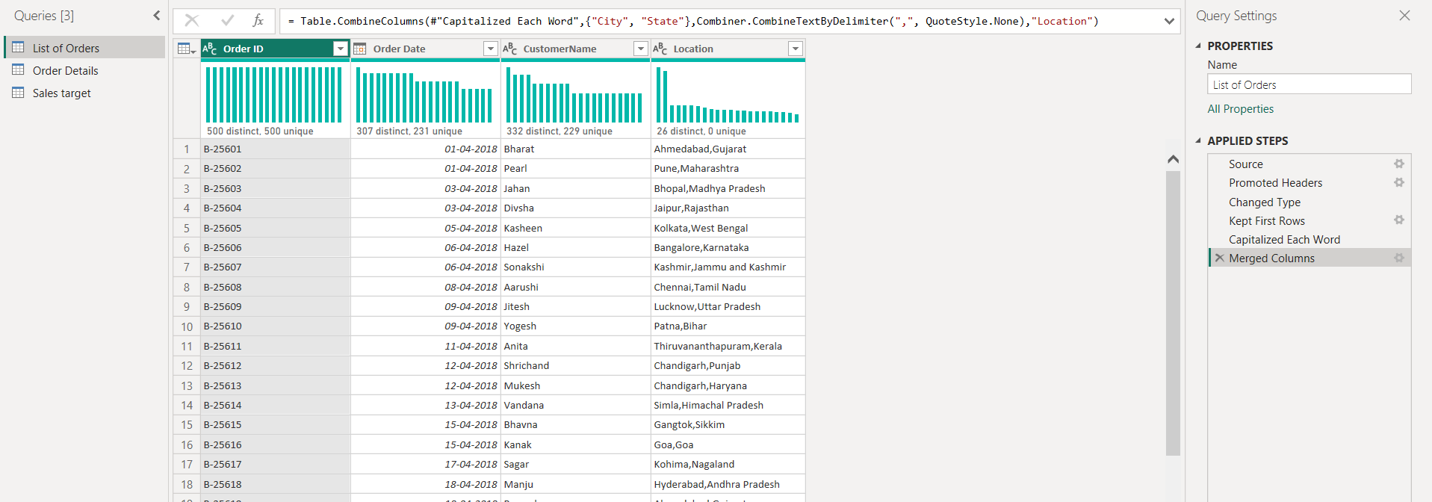
○ Create a custom column named Profit Margin calculated as: Profit / Amount (expressed as
a percentage)
ANS: The Profit Margin column was created using a custom formula by dividing Profit by Amount the resulting values were converted into percentage format
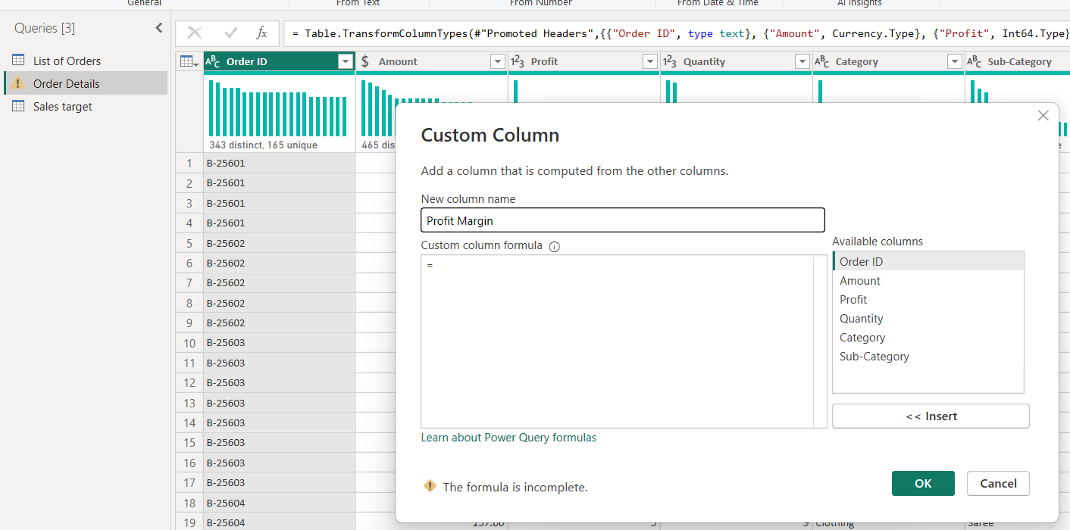
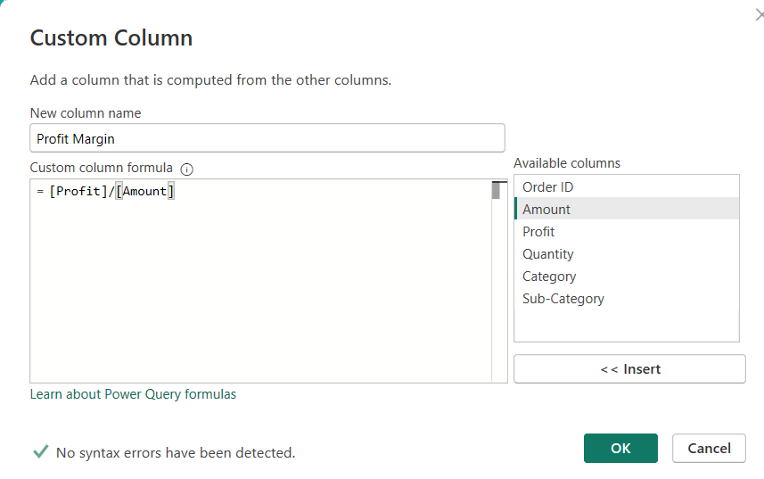
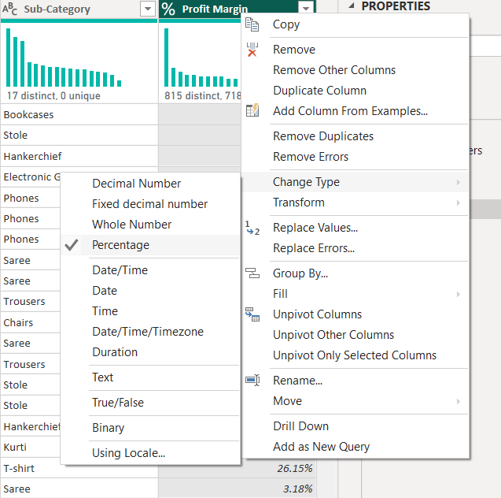
5. Conditional Column:
○ Add a conditional column named Profit Status based on:
■ Profit < 0 → Loss
■ Profit = 0 → Break-Even
■ Profit > 0 → Profit
ANS: A conditional column named Profit Status was created to categorize transactions as Profit, Loss, or Break-Even based on the profit values
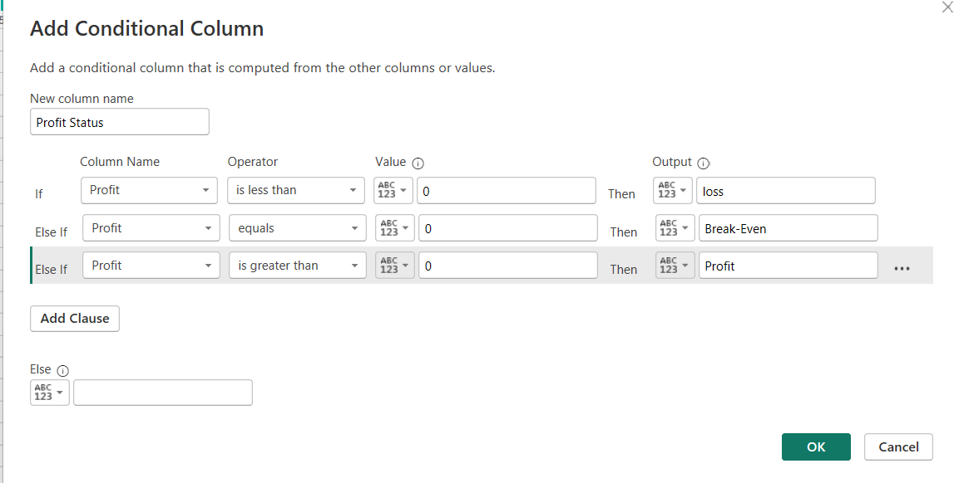
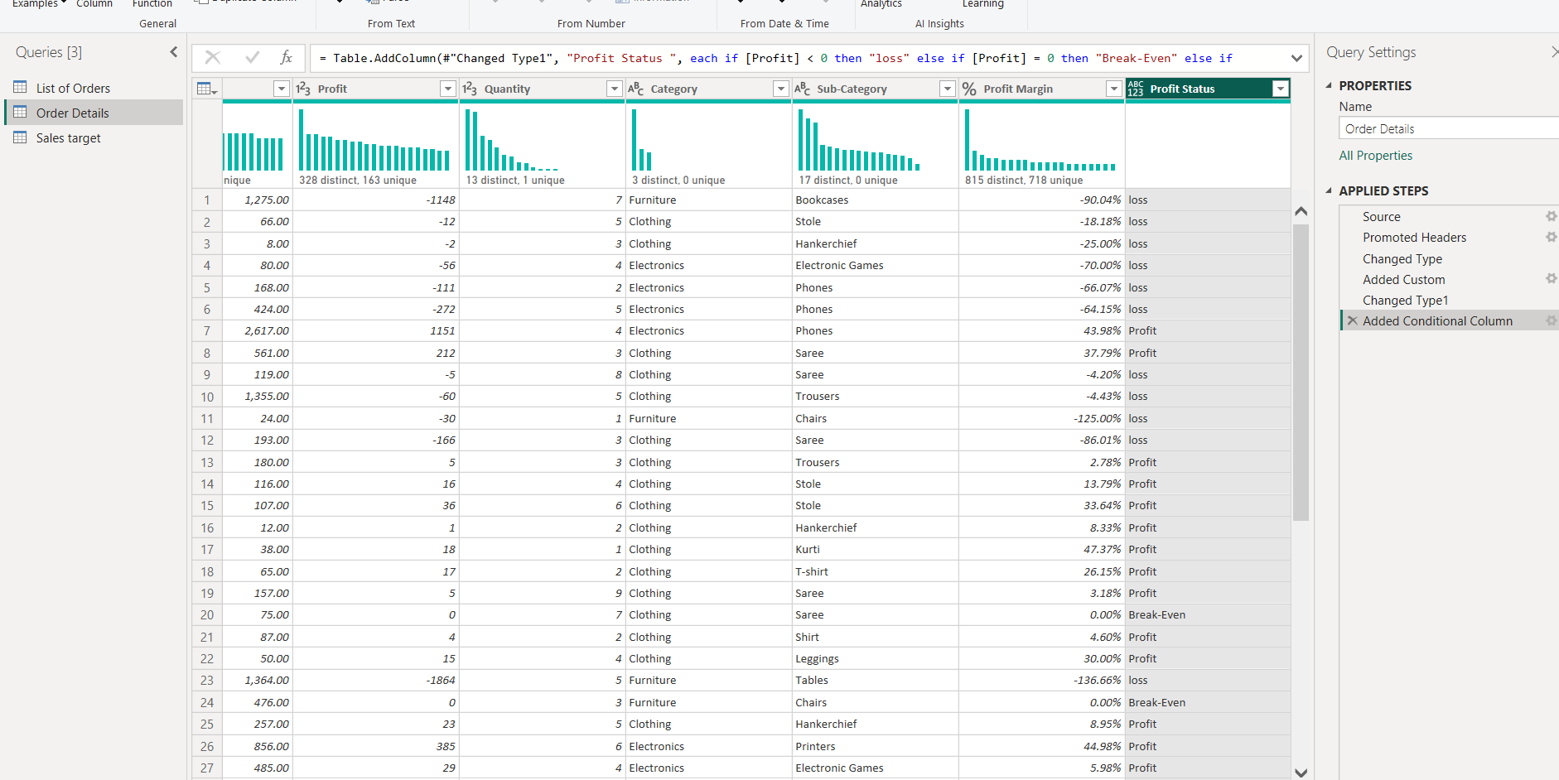
6. Merging Data (Joins):
○ Merge the List of Orders and Order Details tables using Order ID.
ANS: The List of Orders and Order Details tables were merged using the Order ID column
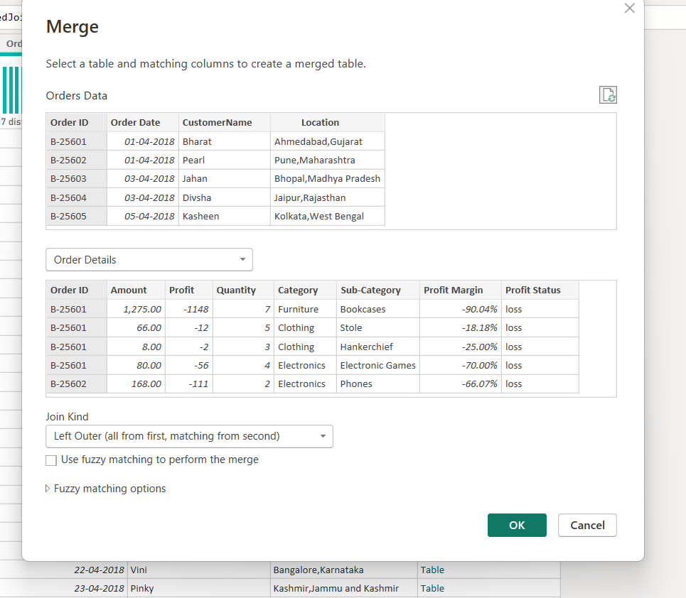

○ Name the merged output table as Orders Data.
ANS: The merged output was renamed as Orders Data to combine order-level and product-level information into a single table for analysis
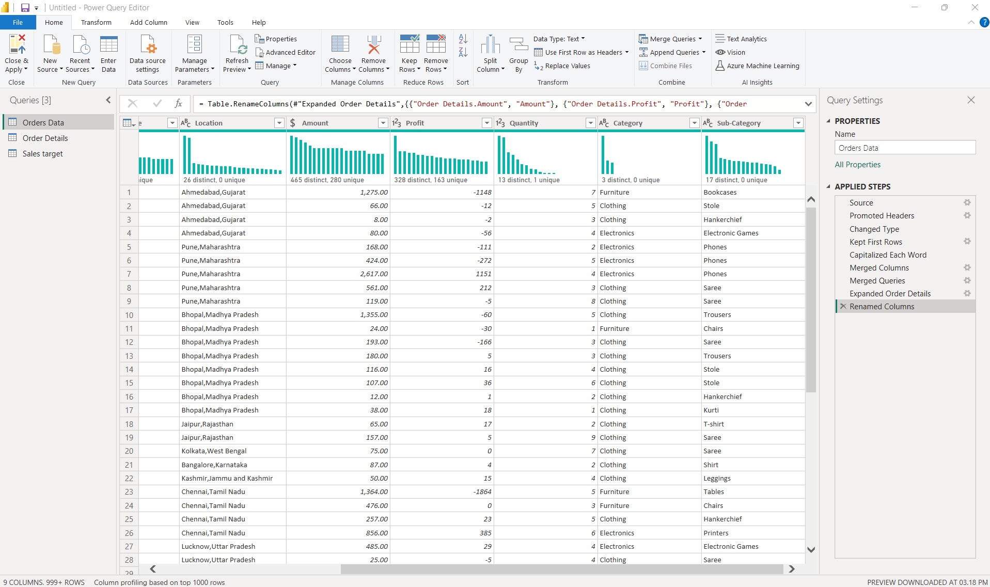
7. Handling Missing Data & Duplicate Data:
● Identify missing values across all tables.
ANS:
All tables were inspected for missing values using column filters in Power Query Editor no null or missing values were identified in the dataset therefore no replacement or removal operations were required
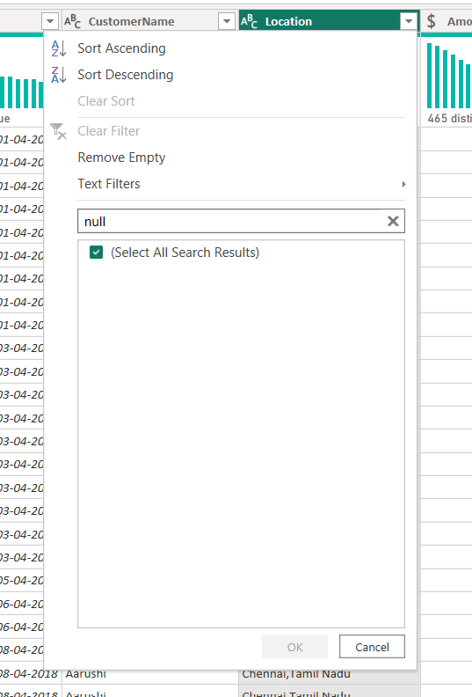
● Define and apply appropriate strategies such as:
○ Replacing missing values
○ Removing records
○ Retaining nulls with justification
ANS:
Possible strategies such as replacing missing values, removing records, or retaining null values based on business relevance were considered during the validation process
● Identify duplicate rows and define a suitable handling strategy based on business logic
ANS:
Duplicate rows were checked across all tables using the Keep Duplicates option in Power Query Editor no duplicate records were identified in the dataset; therefore, no duplicate removal operations were required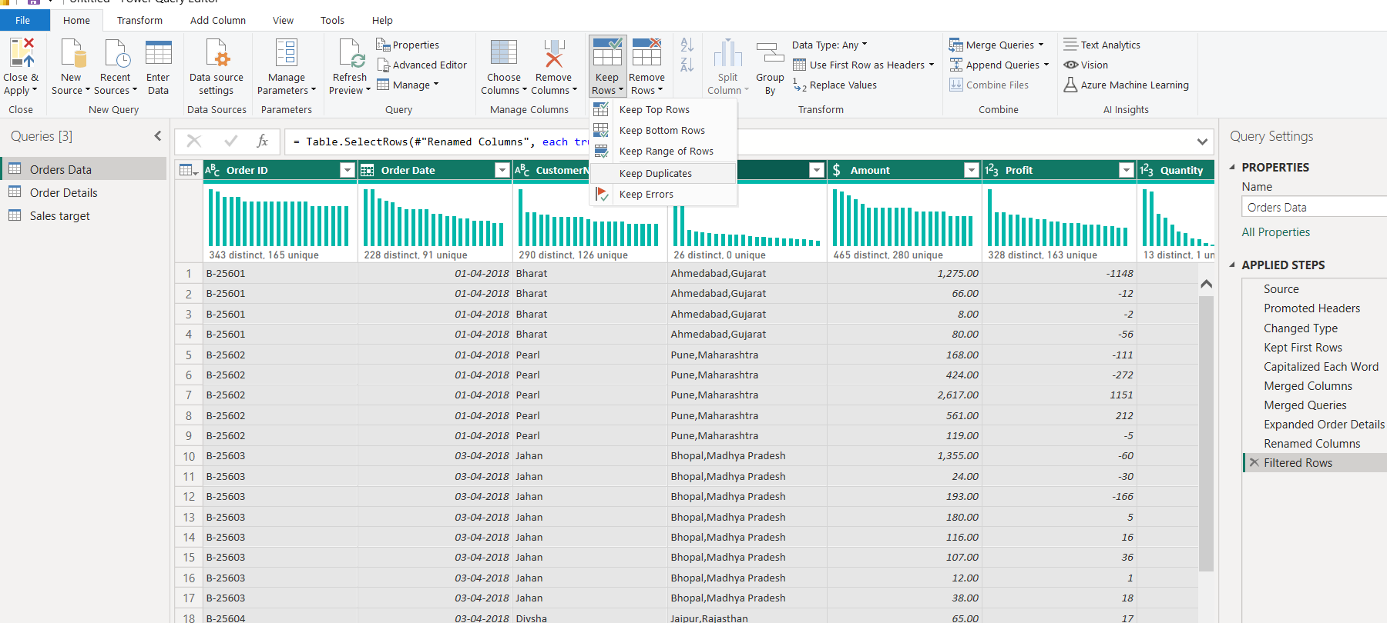
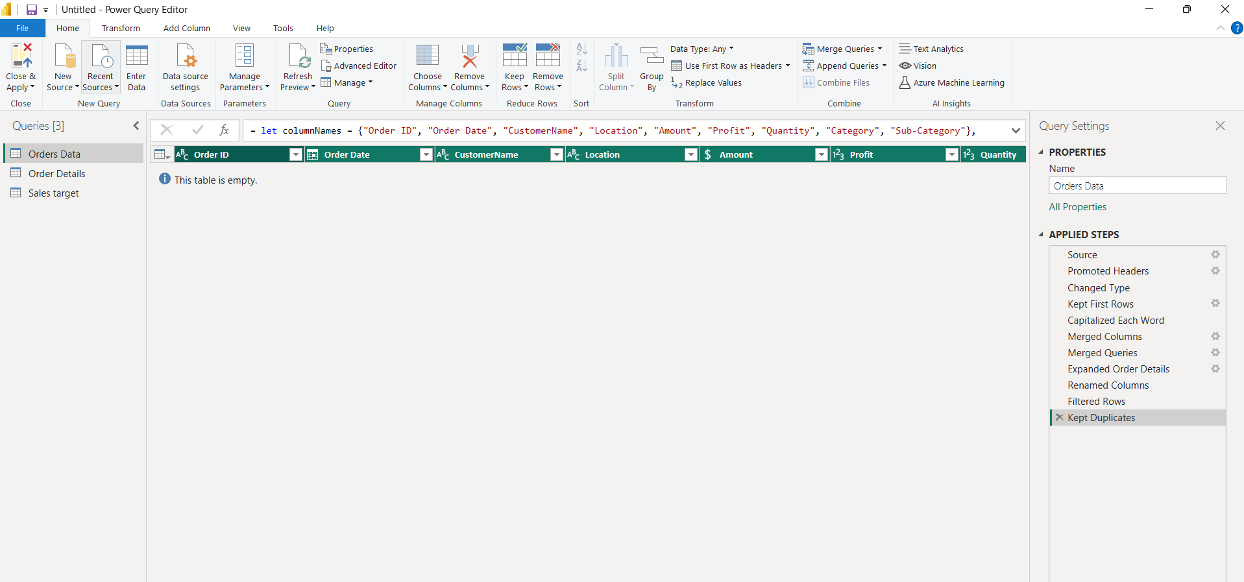
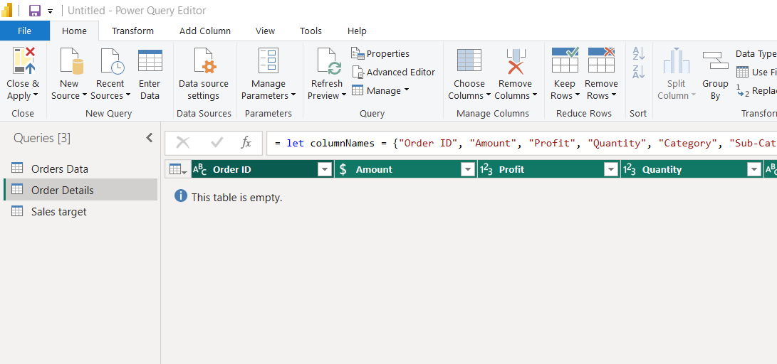
8. Sorting and Filtering Data:
● Sort records in the Orders Data table by Order Date in descending order.
ANS:
Records in the Orders Data table were sorted by Order Date in descending order using the sorting options in Power Query Editor
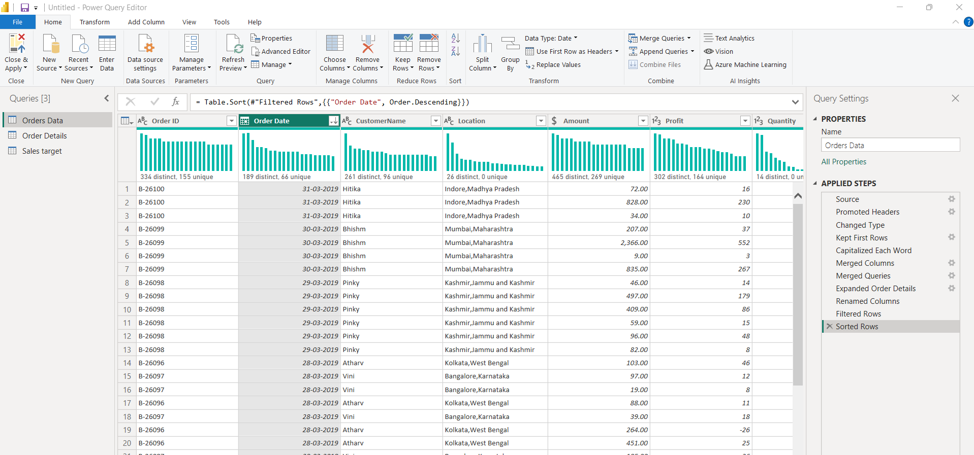
● Apply filters to analyze orders from a specific state (e.g., Tamil Nadu).
ANS: Filters were applied on the Location column to analyze orders specifically from Tamil Nadu
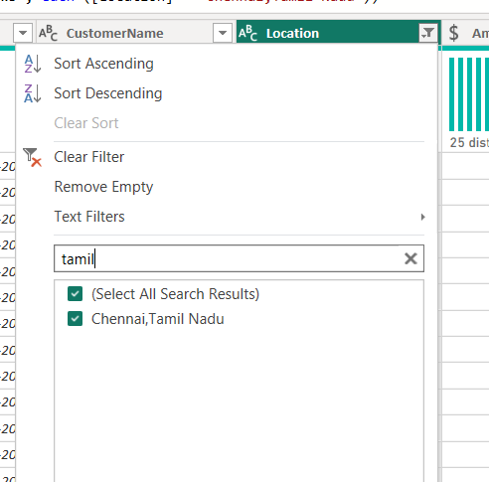
9. Grouping and Aggregating Data:
● Duplicate the Order Details table and perform the following:
○ Count of Order ID
ANS:
The Order Details table was duplicated and grouped by Category to calculate the count of Order IDs using the Group By transformation in Power Query Editor
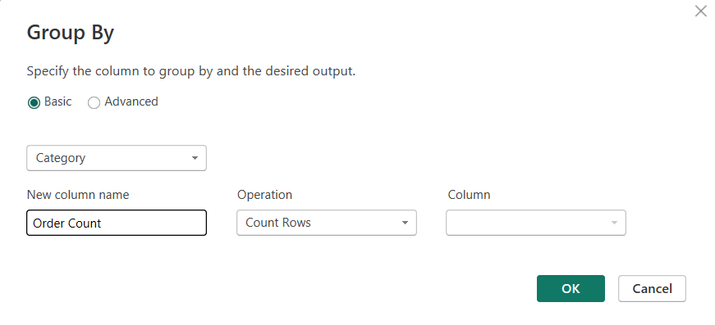
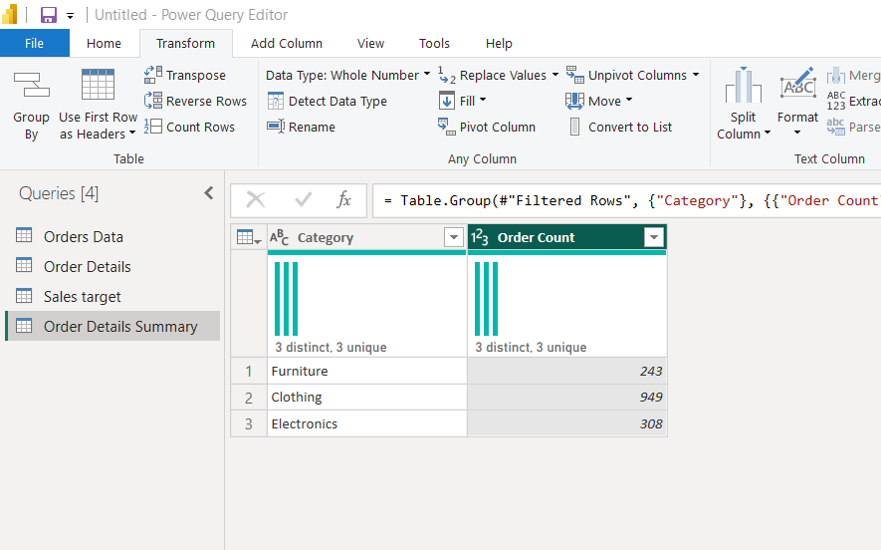

○ Average Profit by Category
ANS:
The duplicated Order Details table was grouped by Category to calculate the average profit for each product category

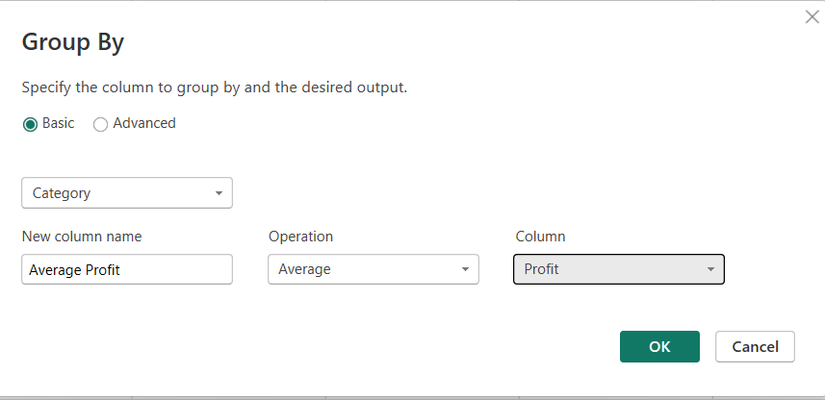
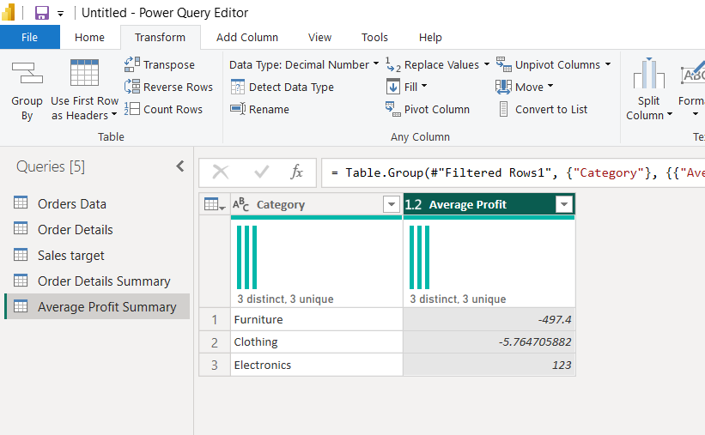

○ Total Amount by Sub-Category
ANS: The Order Details table was grouped by Sub-Category to calculate the total sales amount for each sub-category using aggregation functions

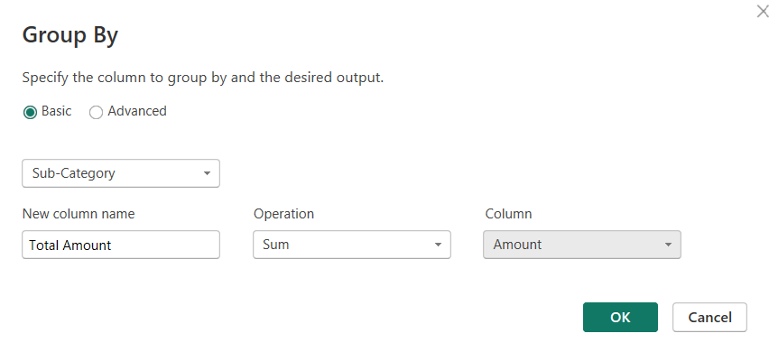
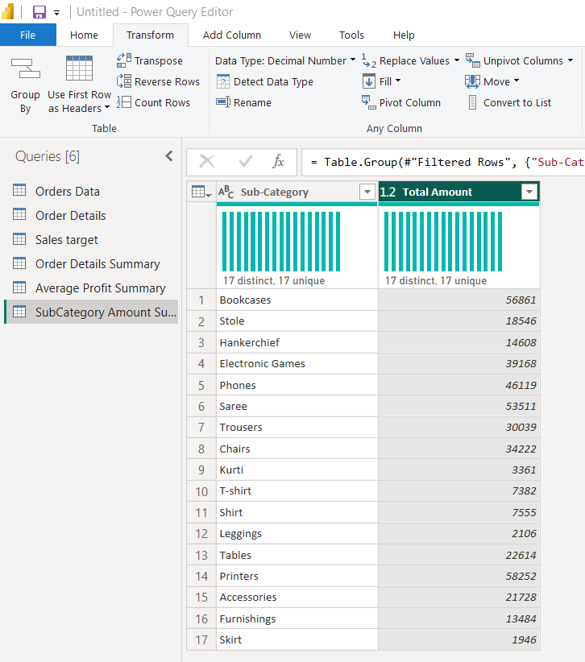

● Duplicate the Sales Target table and aggregate the total Target by Month of order date.
ANS: The Sales Target table was duplicated and grouped by Month of Order Date to calculate the total target values for each month

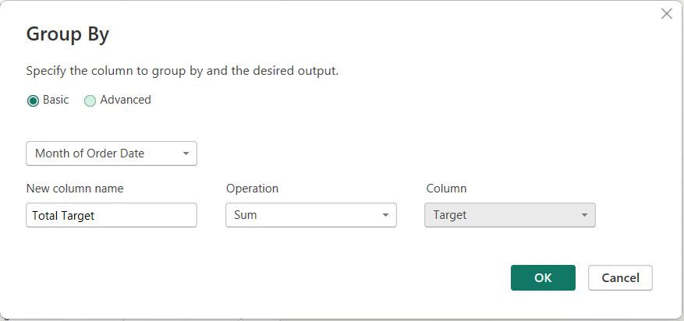
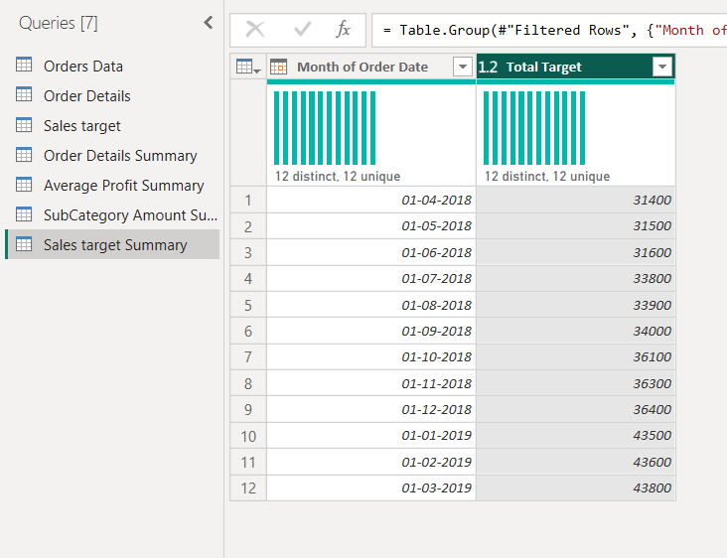

10. Data Modeling:
● Establish a relationship between:
○ List of Orders and Order Details using Order ID
● Establish a relationship between:
○ Order Details and Sales Target using Category
ANS: Relationships were established between the Orders Data and Order Details tables using the Order ID column.
Another relationship was created between the Order Details and Sales Target tables using the Category column.

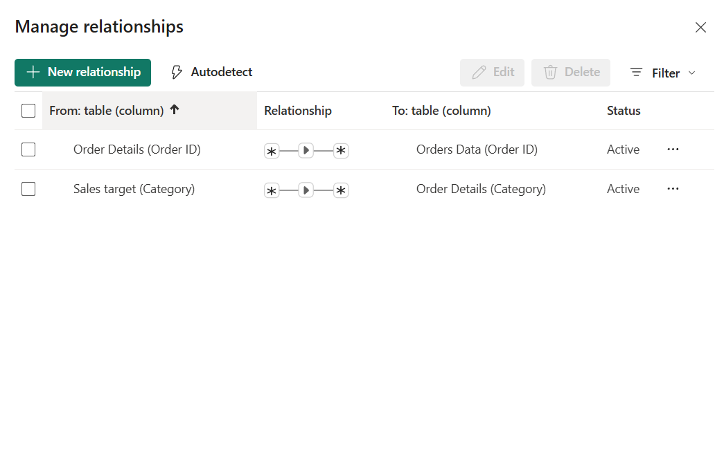

Use Manage Relationships to ensure relationships are active and correctly defined.
ANS: Many-to-many relationships were used because repeated Order ID and Category values were present across related tables as part of the transactional structure of the dataset
